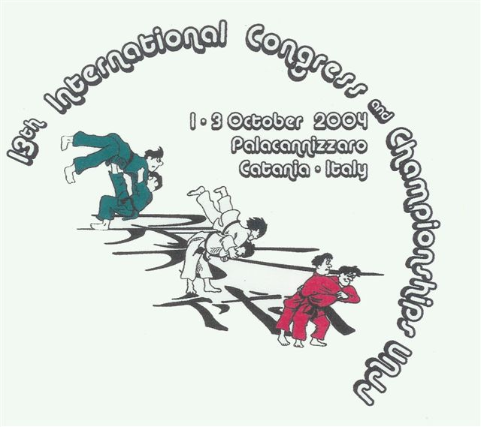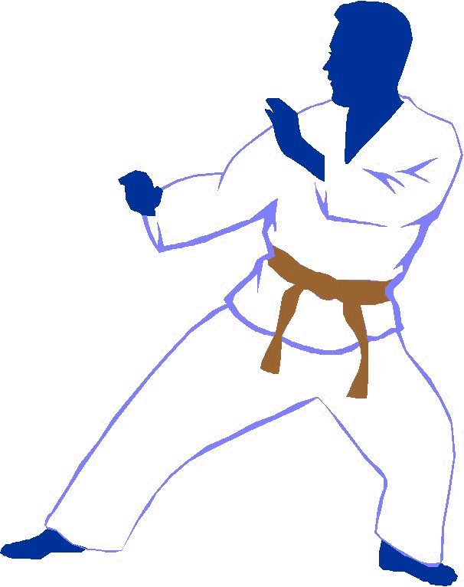
UNITED NATIONS OF JU JITSU
13° Congresso e Campionato Internazionale
United Nations of Ju Jitsu Catania - Italy
1-3 Ottobre 2004

Direzione Stage per l’Italia M° Gery Spina

M° Enzo Pennisi

M° Antonio Labruna

RISULTATI AGONISTICI TEAM ITALIA

CLASSIFICHE

RANDOM-ATTACK
CHILDREN A BEG: GOLD TROVATO DANIELE (BRIZZ-ITALY)
SILVER VALASTRO LUCA (BRIZZ-ITALY)
BRONZE SPADARO SALVATORE (ENNA-ITALY)

CHILDREN A INT: GOLD PARLASCINO GIUSEPPE (ENNA-ITALY)
SILVER MONFORTE GIORGIA (ENNA-ITALY)
BRONZE MONFORTE FEDERICO (ENNA-ITALY)

CHILDREN B BEG: SILVER MONASTERI DENISE (ENNA-ITALY)

CHILDREN B INT: GOLD BORGESE NICOLO’ (BRIZZ-ITALY)
BRONZE VALASTRO ALFIO (BRIZZ-ITALY)

)

JUNIOR FEMM. BEG: BRONZE RAPPAZZO JESSICA (DAIKO-ITALY)

JUNIOR INT: SILVER MUNIZZI MANLIO (OIKOS-ITALY)

JUNIOR ADV: SILVER INTERLANDI GIORGIO (BRIZZ-ITALY)
BRONZE VIOLA CARMELO (DAIKO-ITALY)

JUNIOR FEMM. ADV: SILVER RUSSO FEDERICA (BLACK BELT-ITALY)
BRONZE TRAMONTANA ANTONELLA (DAIKO-ITALY)

JUNIOR BB: SILVER SALVAGGIO DAIKO (DAIKO-ITALY)

SENIOR FEMM. BEG: SILVER LA TORRE DEBORA (DAIKO-ITALY)

KATA

CHILDREN A BEG: GOLD INGRASSIA BARBARA (ENNA-ITALY)
SILVER SPADARO SALVATORE (ENNA-ITALY)
BRONZE VALASTRO LUCA (BRIZZ-ITALY)

CHILDREN A INT: GOLD MONFORTE FEDERICO (ENNA-ITALY)
BRONZE SPINELLA SANTINO (DAIKO-ITALY)

CHILDREN B BEG: SILVER BUTTAFUOCO SALVATORE (ENNA-ITALY)
BRONZE MONASTERI DENISE (ENNA-ITALY)

CHILDREN B INT+ADV: GOLD NICOTRA MARTINA (ENNA-ITALY)
BRONZE SAMARCO ERMINIO (ENNA-ITALY)

CHILD+JUNIOR ADV+BB: GOLD MIRABILE LORETTA (DAIKO-ITALY)

JUNIOR BEG: BRONZE LINCENTI ANDREA (ENNA-ITALY)

JUNIOR INT: BRONZE LO RE FRANCESCA (ENNA-ITALY)

SENIOR BEG: SILVER LA TORRE DEBORA (DAIKO-ITALY)
BRONZE DANCEY BRENT (BLACK BELT-ITALY)

SENIOR BB: SILVER RUSSO DAMIANO (BLACK BELT-ITALY)

WEAPON-KATA

SENIOR ADV: GOLD PARASOLE ROSARIO (BRIZZ-ITALY)
BRONZE GRASSO SIMONE (BRIZZ-ITALY)

SENIOR BB: GOLD RUSSO DAMIANO (BLACK BELT-ITALY)

PAIRS-DEMO

CHILDREN A: GOLD PORCINO S. – MAZZEO V.(DAIKO-ITALY)
SILVER VALASTRO L. – TROVATO D. (BRIZZ-ITALY)

CHILDREN B INT+ADV: GOLD BLANDINO A. – BORGESE N. (BRIZZ-ITALY)
SILVER NICOTRA M. – CENTAMORE S.(ENNA-ITALY)
BRONZE VALASTRO A. – CAVALLARO M. (BRIZZ-ITALY)

JUNIOR BEG: SILVER POLITI V. – CINQUE M. (OIKOS-ITALY)

JUNIOR ADV: BRONZE MAURO A. – COSTA F. (BRIZZ-ITALY)

SENIOR INT: BRONZE MARINO G. – MUNIZZI M. (OIKOS-ITALY)

SENIOR ADV: GOLD MAURO A. – GRASSO S. (BRIZZ.ITALY)

GROUND FIGHTING

CHILDREN A BEG: GOLD PORCINO SALVATORE (DAIKO-ITALY)
SILVER SPADARO SALVATORE (ENNA-ITALY)
BRONZE INGRASSIA BARBARA (ENNA-ITALY)

CHILDREN A INT+ADV: GOLD SPINELLA SANTINO (DAIKO-ITALY)
SILVER MAZZEO VITO (DAIKO-ITALY)
BRONZE MONFORTE FEDERICO (ENNA-ITALY)

CHILDREN B BEG: GOLD SALVAGGIO KERIM (DAIKO-ITALY)
SILVER CAVALLARO MARCO (BRIZZ-ITALY)
BRONZE PRIMAVERA SANTO (BRIZZ-ITALY)

CHILDREN B BEG+INT: GOLD MONASTERI DENISE (ENNA-ITALY)
SILVER SAMARCO ERMINIO (ENNA-ITALY)
BRONZE MONASTERI DANILO (ENNA-ITALY)

JUNIOR BEG: GOLD CINQUE MATTEO (OIKOS-ITALY)

JUNIOR FEMM. OPEN: SILVER LANTERI SILVIA (OIKOS-ITALY)
BRONZE MAZZEO VALERIA (OIKOS-ITALY)

SPARRING

JUNIOR FEMM. BEG: GOLD MAZZEO VALERIA (OIKOS-ITALY)
SILVER LA TORRE FRANCESCA (DAIKO-ITALY)
BRONZE LANTERI SILVIA (OIKOS-ITALY)

JUNIOR BEG+INT: GOLD LINCENTI ANDREA (ENNA-ITALY)
SILVER MANNINO GAETANO (SPRING TIME-ITALY)
BRONZE CINQUE MATTEO (OIKOS-ITALY)

JUNIOR INT: GOLD MUNIZZI MANLIO (OIKOS-ITALY)
SILVER POLITI VINCENZO (OIKOS-ITALY)

JUNIOR ADV: GOLD INTERLANDI GIORGIO (BRIZZ-ITALY)
SILVER PAPPALARDO LUCIO (BRIZZ-ITALY)

JUNIOR ADV: GOLD D’ OCA FABIO (BRIZZ-ITALY)

JUNIOR BB: GOLD SALVAGGIO DAIKO (DAIKO-ITALY)

SENIOR BEG: GOLD DANCEY BRENT (BLACK BETL-ITALY)
SILVER PAPPALARDO GIUSEPPE (BRIZZ-ITALY)

SENIOR ADV+BB: BRONZE MARINO GIANFILIPPO (OIKOS-ITALY)

SENIOR ADV+BB: SILVER GRASSO SIMONE (BRIZZ-ITALY)

DEMO-TEAM

CHILDREN 1° GERMANY P. 263
2° ITALY P. 229
(Scalia Marco,Migliorino Alex,Blandino Alessio,Borgese Nicolo’,Valastro Alfio,Cavallaro Marco)

JUNIOR 1° ITALY P. 291
(Russo Federica, Scuto Maurizio, Mauro Angelo, D’Oca Fabio)
2° GERMANY P. 268

SENIOR 1° ITALY “TEAM SAMURAI” P. 291
(La Rocca Francesco, Interlandi Giorgio, Dato Giovanni, Grasso Simone)
2° ITALY “ TEAM FLAG” P. 281
(Labruna Antonio,Russo Damiano,Spitaleri Alberto,Barboso Alessandro,Campese Massimo)
3° GERMANY P. 274

